**VSB ENGINEERING COLLEGE,KARUR-639111**

**IBM NALAYA THIRAN**

**IBM CLOUD**

|  |  |
| --- | --- |
| **Team ID** | **PNT2022TMID33557** |
| **Project Name** | **Project – IOT ENABLED SMART FARMING APPLICATION** |

**TEAM LEAD : NAVANEETHAN R**

**TEAM MEMBER 1: NAVEENKUMAR V**

**TEAM MEMBER 2: KAVINKUMAR P**

**TEAM MEMBER 3: PARTHIPAN G**

**MENTOR : VALLISUSEELA R**

**STEP 1:-**

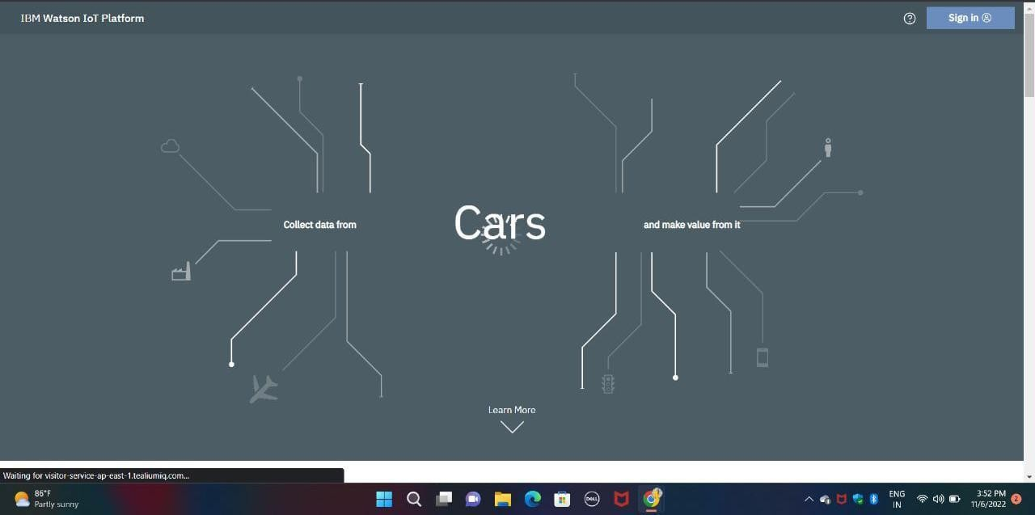

**STEP 2:-**

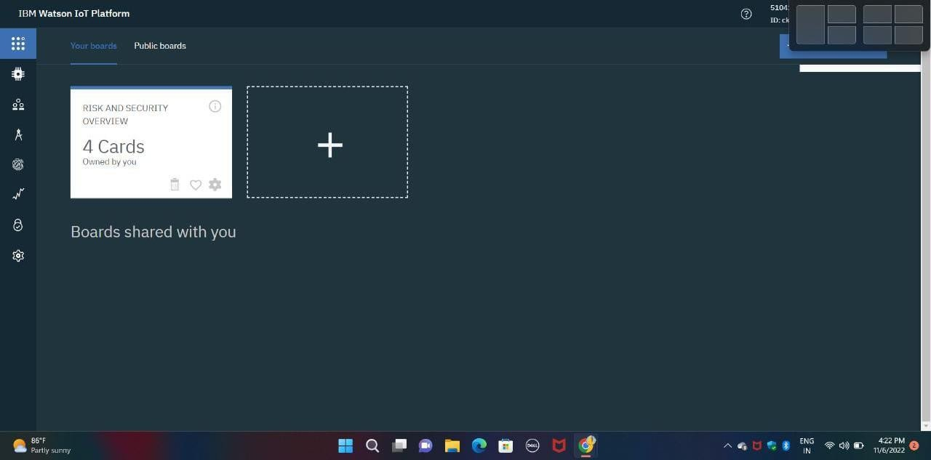

**STEP 3:-**

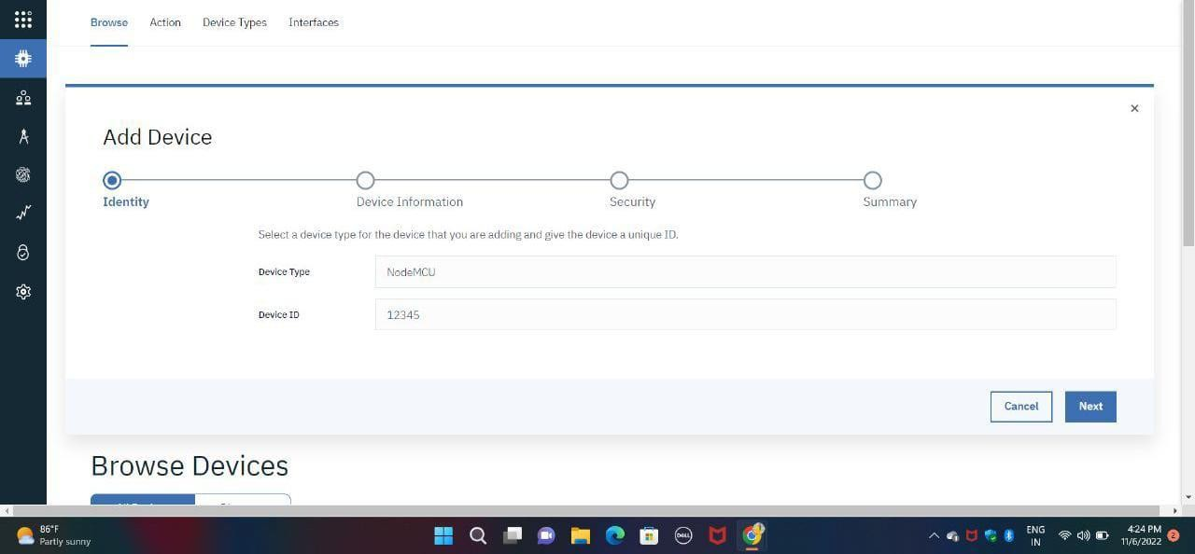

**STEP 4:-**

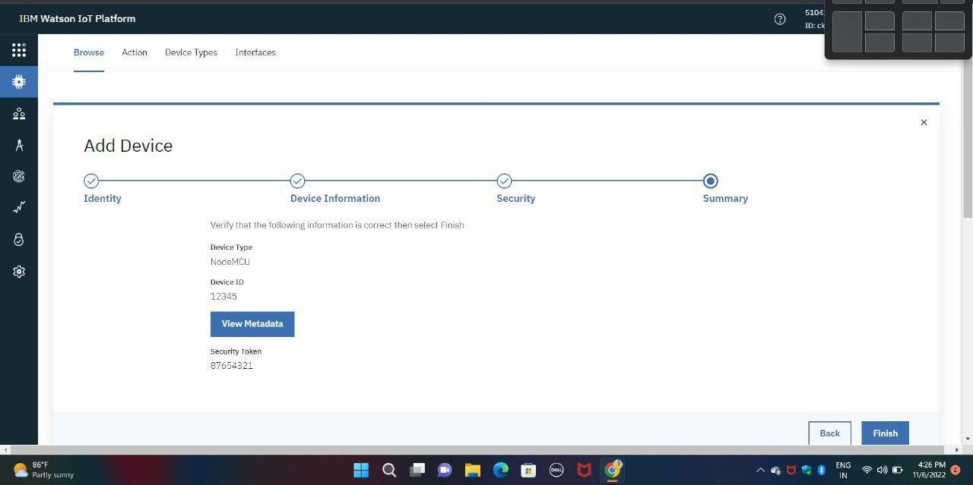

**STEP 5:-**



